UNDER EMBARGO until HOME has announced the award winners on their channels on Thu 3 Mar. Please feel free to share from 9pm Thu 3 Mar.

HOME announce Manchester Open Award 2022 Winners

- HOME announce the 5 winners of the Manchester Open Awards 2022
- £10,000 of prize funding will be distributed to local creative talent

- Prizes include tailored artist development packages managed by Castlefield Gallery and HOME to help guide and invest in their practice, a solo show at HOME’s Granada Foundation Gallery and The People’s Choice Award

- The award-winning open exhibition generates over £23,000 in art sales in first 5 weeks of exhibition

- Last chance to visit The Manchester Open Exhibition ending Sun 27 March

Images can be downloaded here. Additional images are available on request. The event images folder will be uploaded on Friday 4 Mar.

HOME is proud to announce the 5 winners of the Manchester Open Awards 2022.

The Manchester Open exhibition, in HOME’s main gallery from 24 Jan – 27 Mar 2022, is an award-winning biennial open call exhibition celebrating creative talent across Greater Manchester.

Despite the challenges of the pandemic, HOME received an amazing 2,271 artwork entries. There are 474 artworks presented in HOME’s gallery from 446 artists across all ten boroughs of Bolton, Bury, Oldham, Rochdale, Stockport, Tameside, Trafford, Wigan, and the cities of Salford and Manchester.

HOME worked closely with Castlefield Gallery on the selection for this year’s award winners, choosing from a shortlist of 20 artists. The nominated artists have been broken down
into five award categories.

Over £10,000 of prize funding will be distributed between the winning artists, with artist development packages managed by Castlefield Gallery and HOME.
One artist will receive a solo exhibition at HOME in our Granada Foundation Galleries. The final award, The People’s Choice Award has been voted by the public and will receive £250 Cass art voucher and a bespoke development opportunity to be agreed with artist.
These awards and winners are as follows:
- Granada Foundation Gallery Award - Gwen Evans, Portrait of a Woman, Oil, acrylic and airbrush on board (Gallery No.435)
- Castlefield Gallery: Artist Professional Development Award 1 - Gherdai Hassell, Solar, Mixed media collage archival print (Gallery no.409)
- Castlefield Gallery: Artist Professional Development Award 2 - Annabelle Richmond-Wright, Alexa, deconstructed computer chair, hand-stitched foam, latex and found object high heels. (Gallery No. 469)
- Castlefield Gallery: Artist Professional Development Award – 50+ - Nan Collantine, Oceans Apart no.22 (I think it's going to rain today), Oil paint and oil bar on canvas (Gallery No.62)
- The People's Choice Award – Winner Luke Armstrong, Paper Samurai, paper sculpture (Gallery No. 458)
Runners up for The People’s Choice Award are: 2nd place - Michelle Topping, Evade, graphite and colouring pencil on paper, 3rd place - Carlos Feng, Isolation, acrylic on canvas, 4th place – Jen Orpin, Stand Your Ground, oil painting on canvas and 5th place – Arnold Pollock, Kam, film.
Helen Wewiora, Director and Artistic Director, Castlefield Gallery, says:
“It’s an honour to have been asked to be part of the Manchester Open judging panel again. Submissions for the 2022 exhibition evidence the wealth of artistic and creative talent in the city and city region. The finalists shortlisted for the Manchester Open Awards this year further demonstrate a high level of creative skills and artistic promise”.
In the first five weeks, HOME’s award-winning exhibition has generated over £23,000 in art sales with 93 artworks sold, exceeding the inaugural exhibition’s target of £22,000 in 2020.
Kate Royle, Marketing and Sales Officer - Visual Art and Theatre, says:
“It proves that there is demand to support Manchester’s diverse local artists. The Manchester Open also serves as an accessible entry point if you are starting your art collecting journey or you just want to snap up a great work of art. It’s fantastic to see so many artists supporting other artists in these purchases and art lovers supporting local artists!”
The Manchester Open has an accompanying events programme including a performance evening on Thursday 10 March 2022, 19:30.

Full details of the exhibition and tickets can be found online at https://homemcr.org/exhibition/manchester-open-exhibition-2022/

END

Notes to editors

For further information, please contact Julia White, on 0161 212 3463 or email Julia.White@homemcr.org

Audiences can follow the #McrOpen2022 and #ManchesterOpenMonday and HOME’s social media for regular updates about the Manchester Open exhibition and stories behind the artworks.
Watch the trailer for Manchester Open Exhibition 2022 here. Watch a short film Behind the Art: Manchester Open Exhibition 2022 including interviews with 7 artists from the exhibition here.

Manchester Open Performance Evening
Date: Thursday 10 March
Time: 19:30
Location: Theatre 2
Tickets: Tickets are pay-what-you-can £12.50/£7.50/£5
Website: https://homemcr.org/event/manchester-open-2022-performance-evening/

Manchester Open Door Tours
Date: Every Saturday
Time: 2-3pm
Location: Main gallery
Tickets: FREE, booking required
Website: https://homemcr.org/event/manchester-open-2022-performance-evening/

More tours to be announced, please check the website for updates.

HOME Manchester

HOME is Manchester’s centre for international contemporary culture. Since opening in May 2015, HOME has welcomed over three million visitors to its two theatres, five cinemas, art gallery, book shop and restaurants. HOME works with international and UK artists to produce extraordinary theatrical experiences, producing an exciting mix of thought-provoking drama, dance and festivals, with a strong focus on international work, new commissions and talent development.

HOME’s ambition is to push the boundaries of form and technology, to experiment, have fun, take risks and share great new art with the widest possible audience. The patrons of HOME are Danny Boyle, actress Suranne Jones, playwright and poet Jackie Kay CBE, artists Rosa Barba and Phil Collins, filmmaker Asif Kapadia, and actress and author Meera Syal CBE. www.homemcr.org | @HOME_mcr | Facebook HOMEmcr

CASTLEFIELD GALLERY:
At Castlefield Gallery (Est. 1984), we make new art possible. We are dedicated to the advancement of contemporary visual art. We are artist facing. We work with artists and creatives in Greater Manchester and beyond, at all career stages. We support them to develop their practice and careers, and to find ways not just to make art, but to make a living. We do this through: our gallery, and its free exhibitions and events that are open to all; through tailored career and practice development support; through our 250-strong artist Associates scheme; through the provision of low-cost studio and project space; through commissions and co-commissions; and through collaboration with universities, including annual graduate programmes that provide mentoring, coaching and more.

For 37 years, we have supported young and older artists, new graduates right through to established artists, connecting them to each other, and to our international network of curators, arts organisations, artists and collectors. Castlefield Gallery’s international work is focused on exchange between artists in the North West of England, and the rest of the world.

We have an established track record in public art commissioning and public realm animation and activation. We are a female led organisation and a registered charity. Castlefield Gallery is an Arts Council England National Portfolio Organisation and Manchester City Council Cultural Partner. Our Artist Patron is the celebrated Ryan Gander, OBE

MANCHESTER OPEN EXHIBITION 2022 IS SUPPORTED BY:

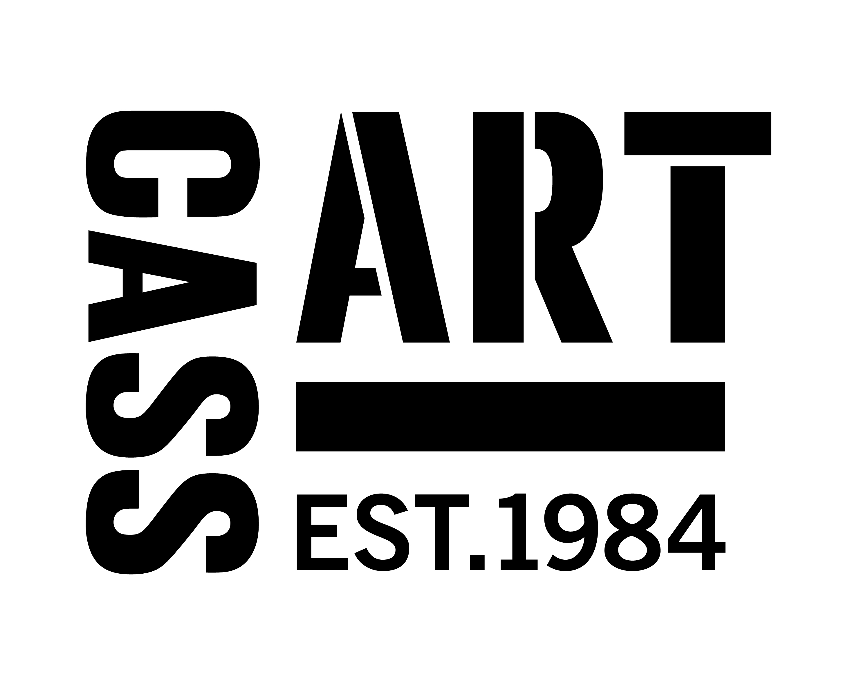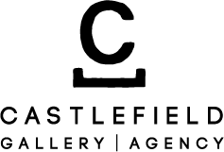

FUNDED BY:
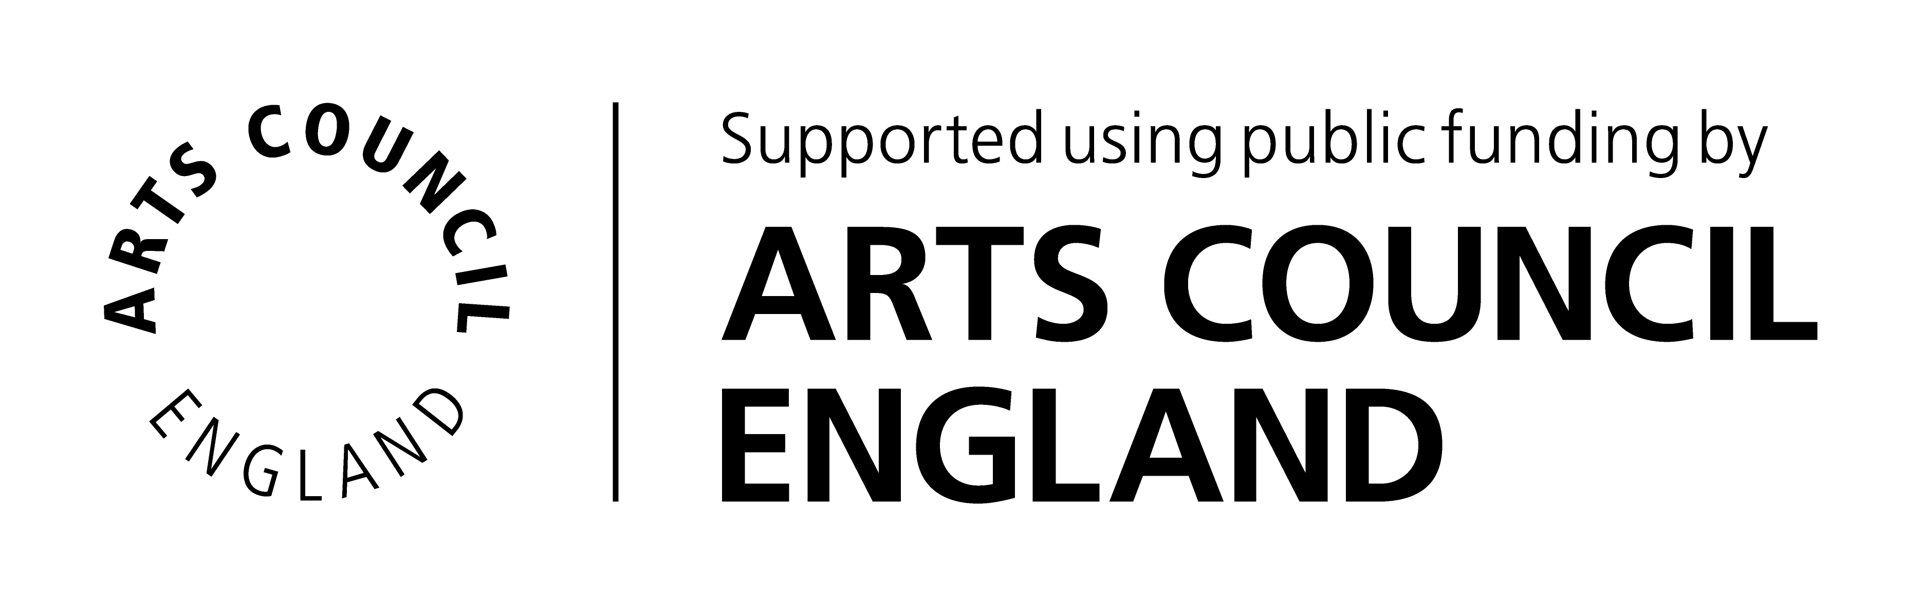


FOUNDING SUPPORTERS:


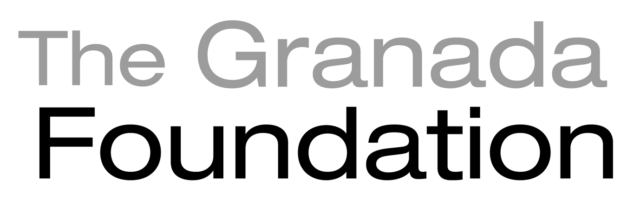
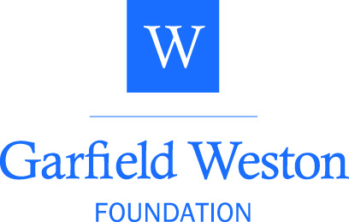

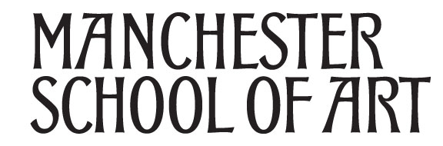
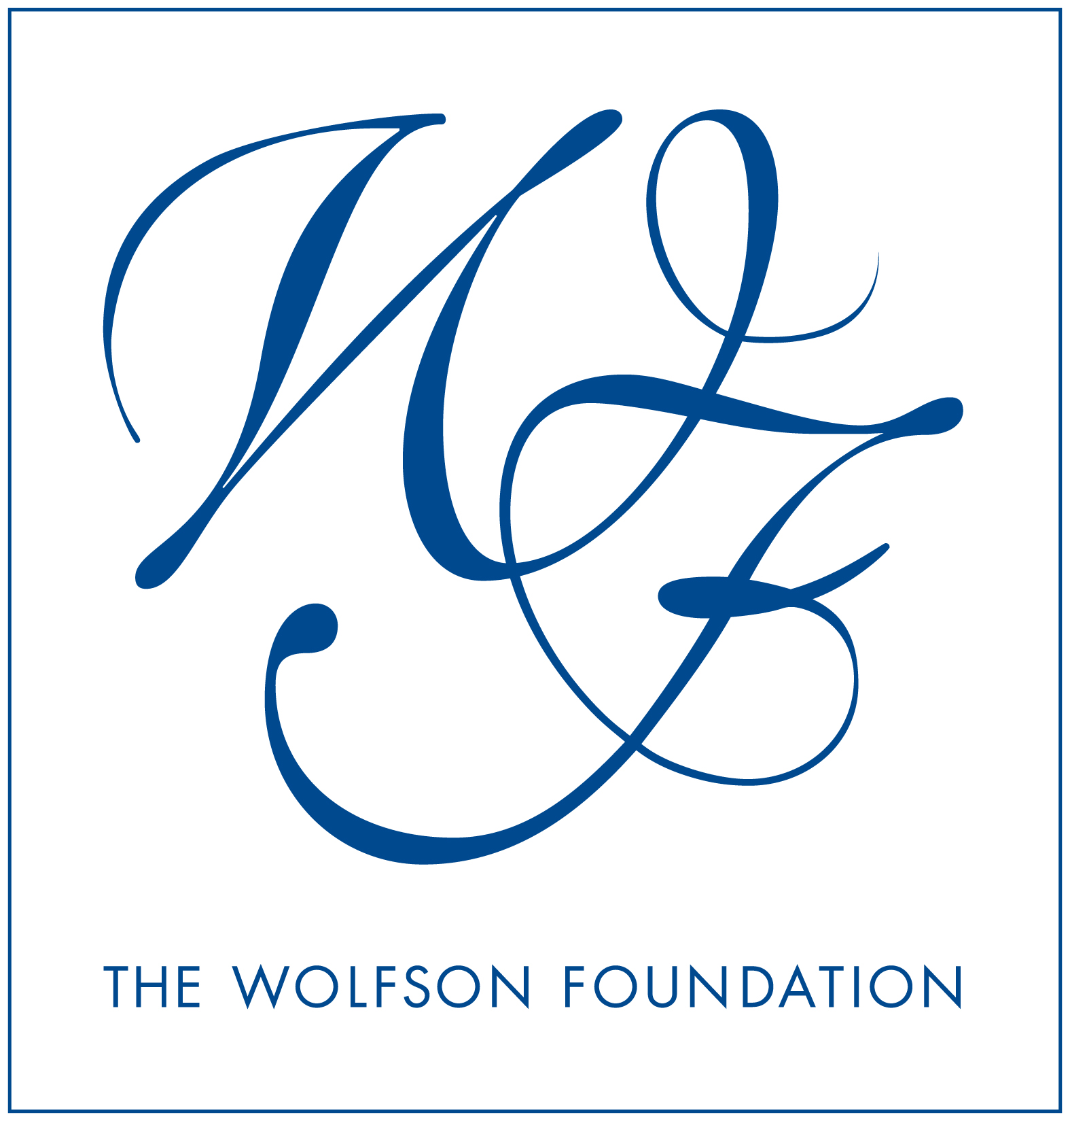


Did you know that HOME is a charity? We need your support to bring the best film, theatre and art to Manchester and inspire the next generation. Get involved at www.homemcr.org/support

