HOME is a trading name of Greater Manchester Arts Ltd
a company limited by guarantee, registered in England and Wales No: 1681278

Registered office 2 Tony Wilson Place Manchester M15 4FN. Charity No: 514719

HOME is excited to announce Fieldnotes, a solo exhibition by artist, maker, educator and climate activist Brigitte Jurack.

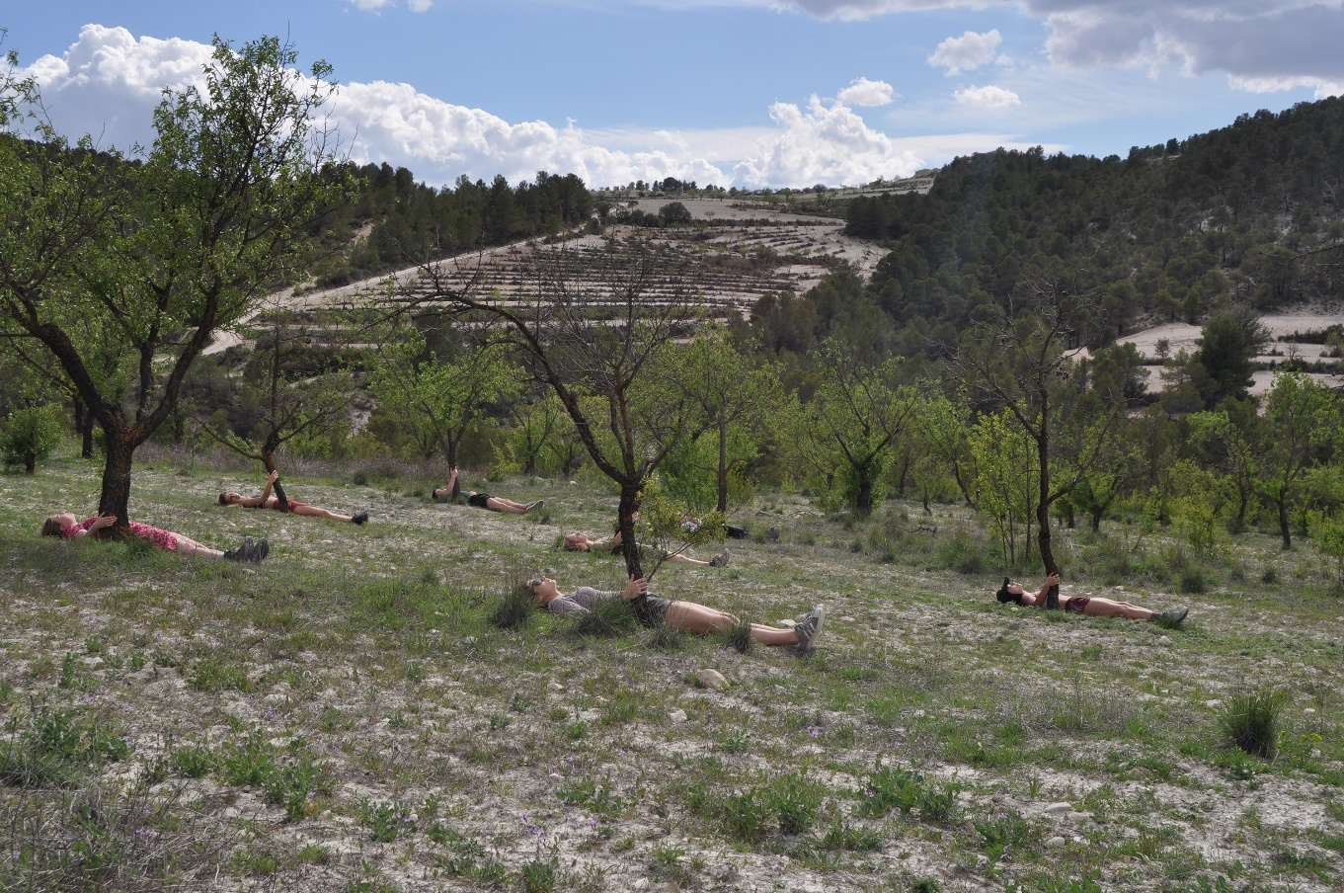
Image: Brigitte Jurack, Spring (Los Gázquez),2018 and Wadi Walks

Brigitte Jurack: Fieldnotes
Exhibition dates: 29 Oct 2022 to 29 Jan 2023
Preview: 28 Oct 2022 6-9pm

HOME is delighted to present Fieldnotes by artist, maker, educator and climate activist Brigitte Jurack, her largest solo show to date. Bringing together works produced in the UK, Spain and India over the last 4 years, her multimedia art practice spans ceramic sculpture, drawing, collaborative happenings and video. Her works stem from a longstanding interest in mythology and fables and express a reverence for the natural world and environmental sustainability; craft and labour, as well as speaking to the extraordinary current times.

The key works in the exhibition will include Best done in winter (2021), a regular programme of skep making workshops. Visitors will be invited to learn to make straw beehives used in medieval farming, now superseded by modern day box hives. The project calls into question the impact of industrial-scale agri-chemical farming on biodiversity and interdependency of species, pollination and the importance of crop rotation in food production, through a reengagement with this endangered craft.

A series of photographs Spring (Los Gázquez),2018 and Wadi Walks, Cities can Dream (2022) reference the different ways in which water has become an increasingly scarce natural resource. Produced in two vastly different European climates, Dovestones, Greater Manchester and one of the most arid, Joya in heart of the Sierra María-Los Vélez Natural Park, Spain, the works depict farmland where demand for water has exceeded supply, and due to climate change and decreased rainfall, can no longer operate. Here, Jurack has documented collaborative happenings with students, conceived not as performances but intuitively choreographed actions in a homage to water. Reimagining our relationship to landscape.

From distance you are so beautiful (2021-) is a diaristic series of works on paper inspired by biological specimen drawing, started during the Covid 19 pandemic. Practiced as an exercise or meditation in looking, drawings of rocks and fungi depict forms or landscapes stripped back to their abstract elements as a tool for connecting to the land. A series of photographs document watercolour mark-making on rocks in a dry riverbed, playing with geometric micro structure and optical illusions, through colour, shape and repetition; a process of negotiating shape-shifting natural form, soon to be washed away by the rain. Jurack has created a space for visitors to draw or paint on a range of natural objects to explore the relationship of form and surface in 3 dimensions, embracing chance and bringing a heightened sense of self.

Meanwhile, Scavengers (2018-21) ‘documents’ the idiosyncrasies of foxes, crows and monkeys in the medium of ceramics continuing the artist’s study of form, through an engagement with the haptic qualities of clay. Produced in India and the UK these 40 animals populate different spaces throughout the gallery. The ubiquitous, often anthropomorphised animals are significant in both cultural and religious symbolism. Known for their intelligence, wit and ability to adapt, they populate urban spaces where concrete and wilderness merge, and where forgotten urban spaces can host greater biodiversity than industrial farmland.

At a time when we have been required to make significant and once unimaginable changes to our lives, this work highlights the importance of everyday creativity, fresh air, access to greenery in nurturing our mental wellbeing, Jurack’s exhibition urges us to consider our individual relationship to the natural environment, climate change in shaping a new future.

Curated by HOME. Produced by HOME and Manchester School of Art, Manchester Metropolitan University.

ENDS

Notes to Editors:

For interviews and additional information, please contact Julia White, Head of Communications at HOME, on 0161 212 3463 or email julia.white@homemcr.org

Please see the exhibition webpage here

Please contact Julia via email to book your attendance at the Exhibition Preview on Fri 28 Oct from 6-9pm.

Brigitte Jurack studied at the Kunstakademie Düsseldorf. She works in the UK where she co-founded the artists’ collective Foreign Investment. She is a Reader and leads Sculpture/Time-Based Arts at Manchester School of Art, Manchester Metropolitan University, where she is also the International Lead for the Department of Art and Performance. Jurack is based in the Liverpool City Region, having transformed a Victorian Bakery into the Alternator Studio and Project Space.

Jurack’s work has been exhibited widely in exhibitions at FILET (London); IMMA (Dublin); Kunsthalle Düsseldorf and Bluecoat (Liverpool). She has held fellowships at the British School at Athens, ICI Redcar, EKWC Hertogenbosch, the Sanskriti Foundation, New Delhi. She published Irfaran, Travel and Work (2007), a book, which focussed on the artist as globetrotting worker in the twenty-first century. Her most recent publication and exhibition What’s left behind (2021) concentrates on adaptability, wit, intelligence and play in the light of growing environmental pressures.

HOME is Manchester’s centre for international contemporary culture. Since opening in May 2015, HOME has welcomed over four million visitors to its two theatres, five cinemas, art gallery, book shop and restaurants. HOME works with international and UK artists to produce extraordinary theatrical experiences, producing an exciting mix of thought-provoking drama, dance, and festivals, with a strong focus on international work, new commissions and talent development.

HOME’s ambition is to push the boundaries of form and technology, to experiment, have fun, take risks and share great new art with the widest possible audience. The patrons of HOME are Danny Boyle, actress Suranne Jones, playwright and poet Jackie Kay CBE, artists Rosa Barba and Phil Collins, filmmaker Asif Kapadia, and actress and author Meera Syal CBE. www.homemcr.org | @HOME_mcr | Facebook HOMEmcr

FUNDED BY:

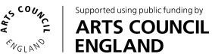

FOUNDING SUPPORTERS:
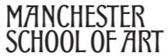

Did you know that HOME is a charity? We need your support to bring the best film, theatre and art to Manchester and inspire the next generation. Get involved at www.homemcr.org/support

